PROCESS OF SETTLING SELF-FINANCING FEE BASED ON INVOICE BY A COMPANY/ENTERPRISE IN THE NEPTUN SYSTEM
If the self-financing fee of the student is paid by a company or enterprise based on an invoice, the entire process can be administrated in the Neptun system using electronic requests as follows.
The person responsible for issuing invoices in the Neptun system for the company or enterprise is the colleague handling billing matters at the Neptun Office. If the student's self-financing fee is paid by a company or enterprise based on an invoice, then the following procedure should be followed.
Procedure:
- The student is obligated to submit a declaration of intention regarding the payment of the self-financing fee, specifying the percentage of the fee to be paid by the employer or another legal entity. The necessary declaration can be found in the Neptun system under the Administration/Requests menu, in the "Fillable requests" tab, named "OE-0003 - Declaration for Payment of Tuition Fee." (Detailed information on submitting the request can be found in Appendix 1).

- In the Finance/Settings menu, under the "Organizations" tab, the student should have the company or enterprise that will settle the self-financing fee based on an invoice listed. If this has not been set up previously, clicking the "New own organization" button allows selecting the company from the appearing list. If the desired organization is not listed in the existing options, the student needs to register the organization's details. By clicking the "Add new organization" button in the pop-up window, the necessary information can be provided, and the Neptun Office will approve it within a few working days after registration. After approval, the student must select the company as their own organization in the aforementioned menu.
If the company or enterprise is not listed in the Finance/Settings menu under the Organizations tab, the student will not be able to submit the request named "OE-0019 - Declaration for Invoice Request."

- In case of requesting an invoice for a legal entity, the student is required to fill out an Invoice Request Declaration as well. The declaration can be filled out in the Neptun system, under the Administration/Requests menu, in the "Fillable requests" tab, using the "OE-0019 Declaration for Invoice Request" request form. (Detailed information on submitting the request can be found in Appendix 2). Please submit the request when the full amount has already been specified in the Neptun system.

- In the next step, in the Finance/Payments menu, by clicking on the "+" sign on the right side of the listed item, and then on "Payer," the student can set the paying organization for the specific item. After the item is listed, the student has one week to perform this action. After this period, the system will automatically generate an invoice in the student's name for the respective item.
If the student does not provide the payer's details in the Neptun system and does not set the paying organization for the specified self-financing fee, the Neptun Office may impose a late reporting fine due to "Delayed Official Data Reporting." The amount of this fine is specified in the Óbuda University's Student Benefits and Fees Regulations.

- Based on the correctly filled data and requests, the University will issue an invoice for the company. The completed electronically signed invoice can be downloaded and printed by the student in the "Finance/Bills" menu. Once printed, the invoices can be used freely; there is no need for the University's signature and seal on them. If the company requests the invoice to be sent by postal mail, it should be indicated in the "OE-0019 Declaration for Invoice Request" form.
The company should make the payment to the account number indicated on the received invoice. Please initiate the transfer only if the invoice addressed to the company has already been prepared!

- The invoice must be requested before making the payment. Issued invoices can only be modified for an additional fee, which will be charged to the student!

- If the company later reimburses the self-financing fee paid in advance by the student (Cafeteria system), in that case, the student should complete the item through the Neptun system, and after the payment, change the "Payer" to the "Organization," as described earlier. In this case, the "OE-0019 Declaration for Invoice Request" request form must also be submitted. The completed invoice will indicate that no financial settlement is required. Please, in this case, indicate in the Remarks section of the request that you would like to request an invoice that does not require financial settlement.

A fentiekről összefoglalást nyújt az alábbi folyamatábra. Az egyes lépések részletes ismertetését a leírás tartalmazza.

A számlázás folyamata (főbb állomások)

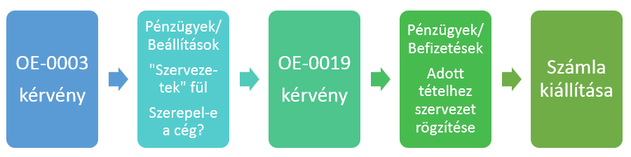

Budapest, 2021.03.30.

Neptun Office
Óbuda University

- Appendix I

OE-0003 - Declaration for Payment of Cost Reimbursement Fee

Submitting the "Declaration for Payment of Cost Reimbursement Fee - OE-0003" request through the Neptun system is done as follows:
- The student logs in to the Neptun system: https://neptun.uni-obuda.hu/hallgato/login.aspx
- If the student has/had multiple programs at Óbuda University, then they select the program for which they wish to submit the request by clicking on "Képzés" (Education) in the upper left corner.

- The fillable requests can be found in the "Ügyintézés/Kérvények" (Administration/Requests) menu under the "Kitölthető kérvények" (Fillable Requests) tab.
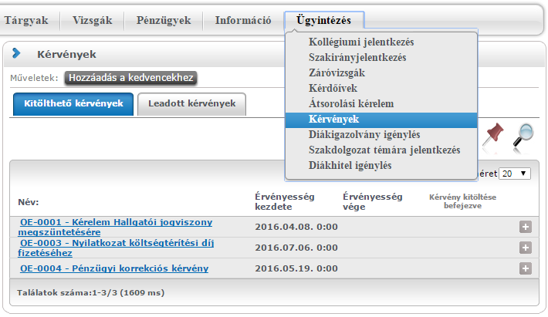

- Opening the request for completion can be done in two ways:
  - By clicking on the name of the request.
  - By clicking on the "+" icon next to the request's name, then in the small pop-up window, clicking on the "Kiválaszt" (Select) button.
- On the request, the student fills in the requested information as follows:
  - As the first step, the student selects from the options how they intend to settle the tuition fee:
    - The employer or another company pays the full tuition fee based on an invoice request declaration.
    - Full payment through student loan concession.
    - Partial payment by the employer or another company based on an invoice request declaration.
    - Partial payment through student loan concession.
    - Partial payment by the employer or another company based on an invoice request declaration, and partial payment through student loan concession.
  - If the tuition fee is partially covered by the employer or another company based on an invoice request declaration, the student fills in the corresponding section.
  - If the tuition fee is partially covered through student loan concession, the student completes the relevant section.
  - If the tuition fee is partially covered by the employer or another company based on an invoice request declaration, and partially through student loan concession, then both sections need to be filled out with the appropriate information.
  - Afterward, the student provides their contact details:
    - Notification address,
    - Notification phone number,
    - Notification email address.

IMPORTANT! In addition to submitting this declaration, the student has further tasks to complete:
- In the case of requesting an invoice for a legal entity, the student must submit the corresponding request using the "OE-0019 Declaration for Invoice Request" form.
- Submitting this declaration is not equivalent to signing a Student Loan Agreement. If the student does not yet have an active Loan Agreement with the Student Loan Centre, it is necessary to enter into one. For information regarding applying for a Student Loan, detailed information can be found in the "Loan Application" section on the website www.diakhiteldirekt.hu, or you can inquire at the University Student Community Centres (contact information can be found in the "Contact / Student Centres" section on the website www.neptun.uni-obuda.hu).
- After filling out the form, click on the "Next" button at the bottom of the form. This will display a Preview page in A/4 size, where the student can review the information before submitting.
- Then, to actually submit the request, click on the "Submit Request" button at the bottom of the Preview page.

Attention! If, after filling out and reviewing the form, the student does not click the "Submit Request" button and exits the page, the request will not be submitted! In this case, the request will remain in the "In Progress" status, and it will not be forwarded to the student's Academic Advisor. The completion of the form can be resumed or restarted if the student reopens the desired form in the "Administration/Requests" section.
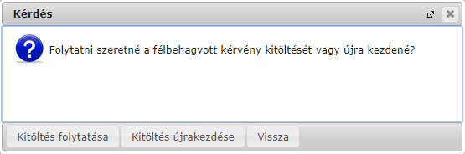

- Submitted requests can be viewed in the "Administration/Requests" section under the "Submitted Requests" tab, where you can verify whether the submission of the request was successful.
On this tab, the student can see the following details regarding the submitted request:
- Name
- Identification number,
- Date of submission,
- Request status,
- Academic advisor,
- Reason for the decision.
- Requests submitted through the Neptun system will be forwarded to the student's Academic Advisor, who will handle further actions related to the request.
- If a decision has been made regarding the student's request, the student will receive an automatic system message in Neptun informing them about the change in the request's status.

- Appendix II

OE-0019 Declaration for Requesting an Invoice

Submitting the "OE-0019 - Declaration for Requesting an Invoice" request through the Neptun system is done as follows:
- The student logs into the Neptun system: https://neptun.uni-obuda.hu/hallgato/login.aspx
- If the student has or had multiple programs at Óbuda University, they should select the program they wish to submit the request for, located in the upper left corner.

- The fillable requests can be found in the "Requests" section under the "Fillable Requests" tab in the "Administration" menu.
- Opening the request for filling can be done in two ways:
  - By clicking on the name of the request.
  - By clicking on the "+" icon next to the name of the request on the right side, and then clicking the "Select" button in the small pop-up window.
- On the request form, the student fills in the following information:
a. Semester: The specific semester for which the student requests the invoice.
b. Self-funding/Reimbursement amount: The total amount of the fee specified in the Neptun system.
c. Buyer's name: Selectable from a drop-down list. The available options are partners' organizations entered in the "Organizations" section under the "Finances/Settings" menu. (Only approved organizations can be set as buyers).
d. Buyer's billing address: A mandatory field that needs to be filled out.
e. Buyer's tax number: Also selectable from a drop-down list.
f. Buyer's group identification number: Selectable from a drop-down list.
g. Buyer's community tax number (for foreign companies only): Selectable from a drop-down list.
h. Buyer's phone number: Contact number of the buyer for the Neptun Office to get in touch regarding any invoice-related queries.
i. Request for sending the invoice: Once the electronic invoice is ready, the student can download it from the "Finances/Invoices" section in the Neptun system. If the student requests the electronic invoice to be sent, they can choose from the available options.
j. Buyer's mailing address: If the student requests the invoice to be sent via postal mail, this field must be filled out. If no mailing is needed, this field can be left empty. Attention! If the mailing preference is selected but the mailing address is missing, the invoice will be sent to the billing address by default!
k. Buyer's email address: If the student requests the invoice to be sent electronically, this field must be filled out. If sending by email is not required, this field can be left empty.
l. Amount assumed by the buyer: Here, the exact amount for which the student requests the invoice to be assumed by the buyer is detailed.
The first field shows the percentage (%) that the buyer assumes from the total self-funding/reimbursement amount. If the buyer is assuming a specific amount instead of a percentage, that amount should be indicated in the second field as a number. In the third field, the student needs to write the assumed amount using letters, whether it's a percentage or a specific amount as indicated in the previous fields.
- After filling out the request form, the student needs to click on the "Next" button at the bottom of the form. Then, an A4-sized Preview page will appear where the student can review the information before submission.
- Subsequently, the actual submission of the request is done by clicking on the "Submit Request" button located at the bottom of the Preview page.

Attention! If, after filling out and reviewing the form, the student does not click the "Submit Request" button and exits the page, the request will not be submitted! In this case, the request will remain in the "In Progress" status, and it will not be forwarded to the student's Academic Advisor. The completion of the form can be resumed or restarted if the student reopens the desired form in the "Administration/Requests" section.

- Submitted requests can be viewed in the "Administration/Requests" section under the "Submitted Requests" tab, where you can verify whether the submission of the request was successful.
On this tab, the student can see the following details regarding the submitted request:
- Name
- Identification number,
- Date of submission,
- Request status,
- Academic advisor,
- Reason for the decision.
- Requests submitted through the Neptun system will be forwarded to the student's Academic Advisor, who will handle further actions related to the request.
- If a decision has been made regarding the student's request, the student will receive an automatic system message in Neptun informing them about the change in the request's status.
- The student will also be notified about the issuance of the invoice through an automatic system message in the Neptun system.

