OE-0045 - Enrolment Form
Guidelines for Students

The submission of the "OE-0045 - Enrollment Form" request through the Neptun system is done as follows:

- The student logs into the Neptun system: https://neptun.uni-obuda.hu/hallgato/login.aspx
- If the student has or had multiple programs at Óbuda University, then in the upper left corner, under "Program," they need to select the specific program for which they want to submit the request.

- The fillable requests can be found in the "Administration/Requests" section, under the "Fillable Requests" tab.
- he request can be opened for filling in through two methods:
  - By clicking on the name of the request.
  - By clicking on the "+" icon next to the name of the request, and then clicking on the "Select" button in the small pop-up window.
- The following two data blocks on the request will be automatically filled in with the information from the Neptun system:
  - Personal data;
  - Educational data.
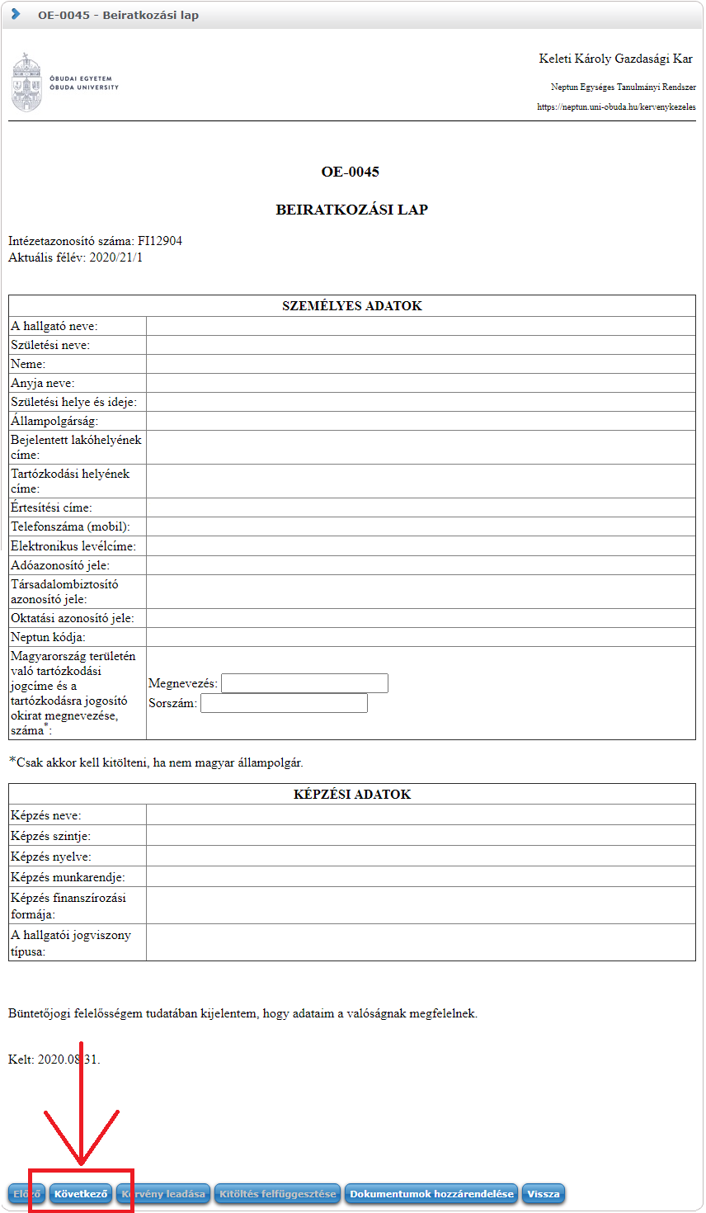

If any of the data is incorrect, please do not proceed with filling out the request. Instead, use the "Back" button to exit the interface. You can review and correct your data in the "Personal Data" section under the "My Data" menu in Neptun. If there are any non-editable fields, you can seek assistance from the Academic Department to override them.
- If everything is correct, you can proceed by clicking the "Next" button. The second page will then appear, containing 2 declarations:

- Then, you can proceed by clicking the "Next" button once again.
- For students enrolled in state-funded education, a third page will appear at this point, containing a declaration stating their acceptance of the terms and conditions of the Hungarian state scholarship (partial or full), as specified in the National Higher Education Act CCIV of 2011, and confirming that they are aware of these conditions.

- To proceed, click on the "Next" button.
Then, the "Preview page" related to the application will appear, where you can review the completed application before submitting it.
(For self-financed students, steps 8 and 9 are skipped, and step 7 is followed directly by step 10.)
- After reviewing the preview, you can finalize the submission of the application by clicking on the "Submit Application" button at the bottom of the page.
ATTENTION! If you do not click the "Submit Application" button and exit the page at the end of the process, the application will not be submitted!

- After submitting the application, the system will offer the possibility to upload application attachments. You must close the pop-up window; there is no action required in this step. The PDF file generated from the application must be uploaded as an attachment later, after authenticating with your client gate.
- You can view the submitted application in the "Submitted Applications" tab under the "Administration/Applications" menu. Here, you can verify whether the application submission was successful.
In this tab, you will see the following information about the submitted application:
  - Name,
  - Identification number,
  - Date of Submission,
  - Application Status,
  - Academic Advisor,
  - Reason for the decision.
- Downloading the generated PDF file of the submitted application can be done in two ways:
  - Clicking ong the name of the submitted application
  - Clicking on the “+” icon next to the application’s row and then selecting the “View” option
This PDF file will need to be authenticated following the procedure described in the next section.

Authentication of the Registration Form through the Client Gate (Ügyfélkapu)

To authenticate the registration form through the Client Gate, you need to log in to the Ügyfélkapu (Client Gate) on the website https://magyarorszag.hu using your own name and password. After logging in, use the search function to look for the following expression: "AVDH," then click on the first link titled "Azonosításra visszavezetett dokumentum hitelesítés" (Document Authentication with Traceable Identification).

After this, we reach the file upload by clicking on the "Start processing" button.

After the upload, you need to select the "Certified PDF" option and check the "I accept the GTC" checkbox, then click on the "Upload" button. The generation of the document takes a few seconds, after which you will be redirected back to the "Identification-based Document Authentication" page. You have the option to download the completed document to your computer or send it via email with its URL for access.

Attaching a certified document to the submitted request
(uploading a request attachment)

Once the certified document is completed through the ügyfélkapu (client portal), it needs to be uploaded to Neptun as an attachment to the previously submitted request.

The submitted request can be found in the Ügyintézés/Kérvények (Administration/Requests) menu under the Leadott kérvények (Submitted Requests) tab.:

You need to click on the "+" icon on the right side of the request row, and then click on the "Kérvénymelléklet" button.
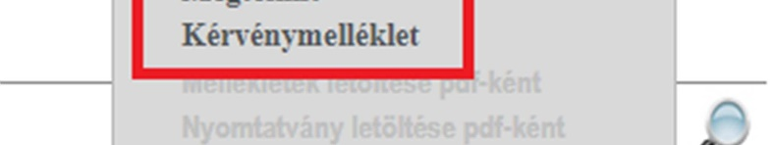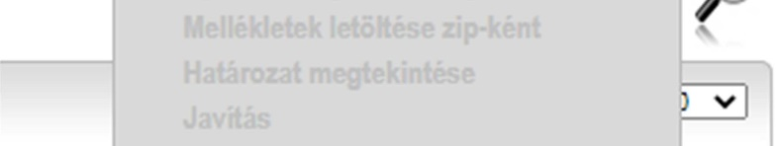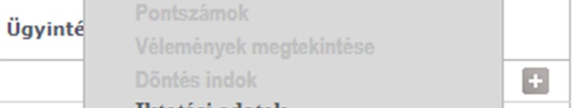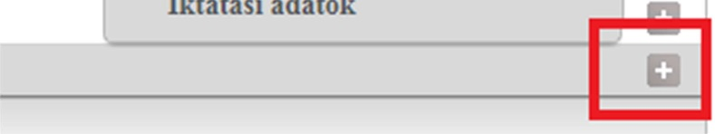

Then, the window for uploading and managing request attachments will appear:

To upload the document, click on the "Upload File" button, and then in the pop-up window, select the file you want to upload.
If the upload was successful, the document will appear in the list under the "Uploaded Request Attachments" section.

Budapest, 2020.08.31.

Neptun Office
Óbuda University

